Supporting Information

**小鼠体内砷甜菜碱向无机砷的生物降解**

赵芊瑜，熊海燕，叶紫君，黄莉萍，张伟*

广州大学，环境科学与工程学院，广州 510006

**附图说明**

**图 S1** 珍珠龙胆石斑鱼饲料中AsB的色谱分析。A为均质器提取的砷溶液，50%甲醇溶液为萃取剂，B为微波消解系统辅助的砷溶液，1% HNO3为萃取剂…..………..…S1

**图 S2** 对照组小鼠心、肝、脾、肺、肾、肠、胃、肌肉中As(Ⅲ)、As(V)、MMA、DMA、AsB的色谱图….………...…………………………………………………………S2

**图 S3** As(Ⅲ)处理组小鼠心、肝、脾、肺、肾、肠、胃和肌肉中As(Ⅲ)、As(V)、MMA、DMA和AsB的色谱图…..…….…. ……………………………………...………S3

**图 S4** As(Ⅴ)处理组小鼠心、肝、脾、肺、肾、肠、胃和肌肉中As(Ⅲ)、As(V)、MMA、DMA和AsB的色谱图…………………………………….…………………...…S4

**附表说明**

**表S1.** SPF级小鼠维持饲料中的各形态浓度(μg·g–1干重)和分布(%)……….………..…S5

**表 S2.** 各处理14天后，小鼠主要内脏器官的各形态浓度(μg·g–1干重)(暴露减去对照处理) …………………………………………………………….………………………...……S6

**表 S3.** HPLC-ICP-MS检测As(Ⅲ)、As(Ⅴ)、MMA(V)、DMA(V)、AsB的仪器参数…………………………………………………………………………………………..…S7

**表 S4.** 不同处理14 天后，小鼠主要内脏器官中BDL(低于检测限)的各形态浓度(μg·g–1干重) ……………….……... ……………….……...…..... ……………...……...…….…...S8

**表 S5.** 不同处理14 天后，小鼠主要内脏器官的形态分布(%)……………….……..…S9

**表 S6.** 在食糜和粪便中的各形态浓度(μg·g–1干重)和分布(%)……………………..... S10

**表 S7.** 小鼠内部组织、粪便和食糜的平均干重(g)………………………………………S11

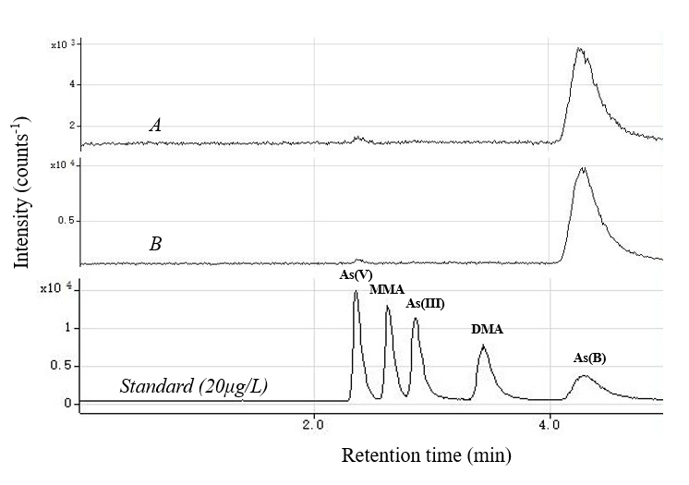

S1

**图** **S1** 珍珠龙胆石斑鱼饲料中AsB的色谱分析。A为均质器提取的砷溶液，50%甲醇溶液为萃取剂，B为微波消解系统辅助的砷溶液，1% HNO3为萃取剂。

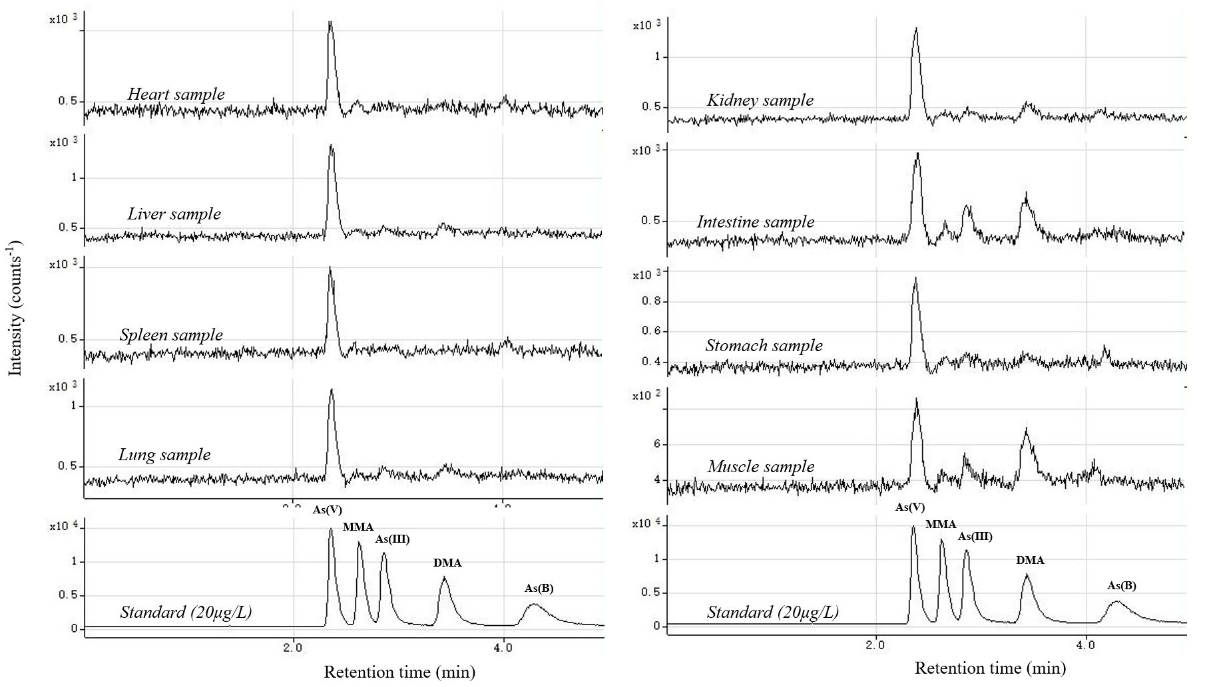

S2

**图 S2** 对照组小鼠心、肝、脾、肺、肾、肠、胃、肌肉中As(Ⅲ)、As(V)、MMA、DMA、AsB的色谱图

S3

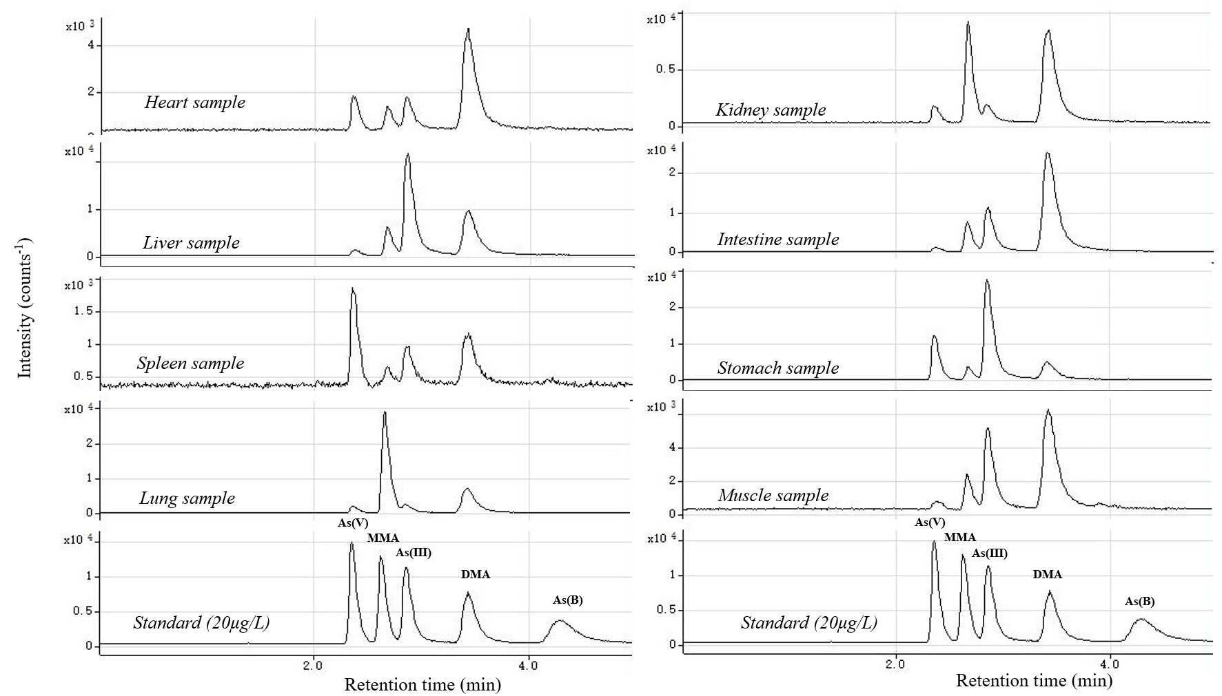

**图 S3** As(Ⅲ)处理组小鼠心、肝、脾、肺、肾、肠、胃和肌肉中As(Ⅲ)、As(V)、MMA、DMA和AsB的色谱图

S4

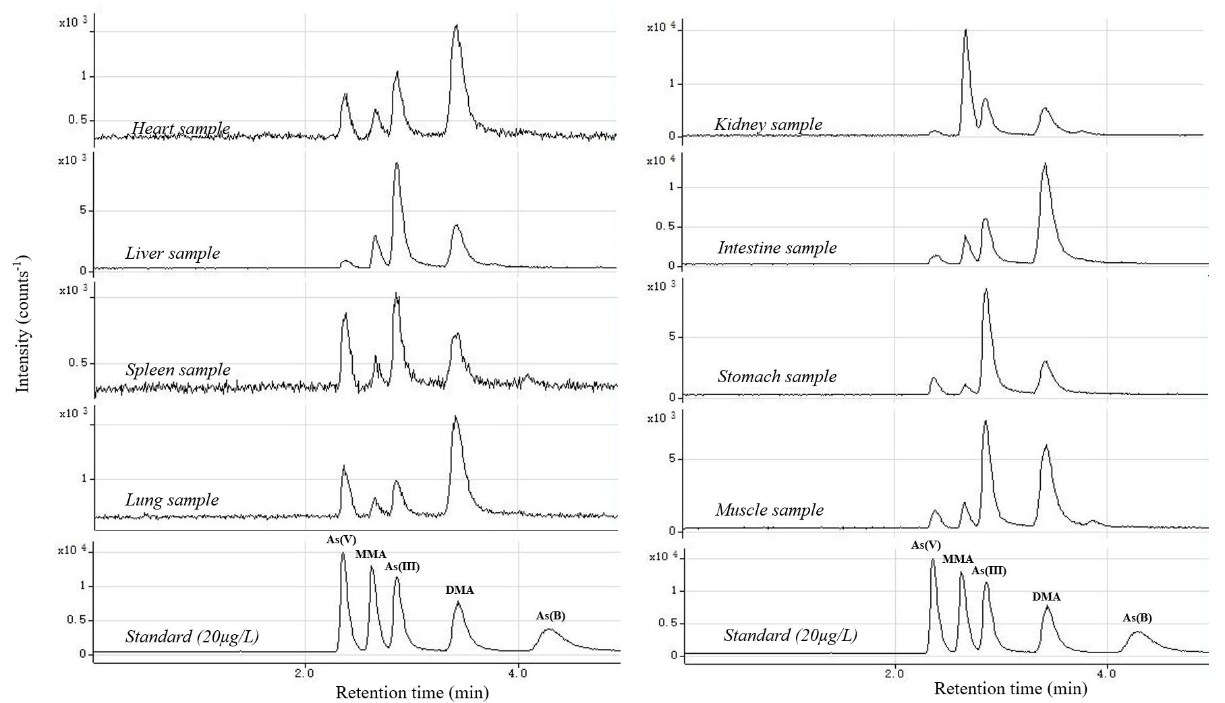

**图 S4** As(Ⅴ)处理组小鼠心、肝、脾、肺、肾、肠、胃和肌肉中As(Ⅲ)、As(V)、MMA、DMA和AsB的色谱图

**表 S1.** SPF级小鼠维持饲料中的各形态浓度(μg·g–1干重)和分布(%)

S5

S7

|  |  |  |  |  |  |  |
| --- | --- | --- | --- | --- | --- | --- |
|  |  | As species concentrations (μg·g–1) and distribution (%) | | | | |
|  | As(III) | As(V) | MMA(V) | DMA(V) | AsB | Column recovery (%) |
| Mouse feed | 0.054±0.009  (18.8±4.47) | 0.180±0.016  (62.1±1.52) | 0.016±0.001  (5.52±0.59) | 0.020±0.008  (6.91±2.21) | 0.020±0.008  (6.71±2.66) | 100.1 |

数据以均值±标准差表示(n = 3)。AsB：砷甜菜碱；As(III)：亚砷酸盐；As(V)：砷酸盐。

**表 S2.** 各处理14天后，小鼠主要内脏器官的各形态浓度(μg·g–1干重)(暴露减去对照处理)

S6

|  |  |  |  |  |  |  |  |
| --- | --- | --- | --- | --- | --- | --- | --- |
| Treatments | Tissues | As(III) | As(V) | MMA(V) | DMA(V) | AsB | Column recovery (%) |
| Control | Chyme | 0.164±0.056 | 0.111±0.057 | 0.047±0.018 | 0.042±0.004 | 0.044±0.007 | 89.1 |
| Stomach | 0.007±0.001 | 0.014±0.000 | 0.004±0.001 | 0.003±0.001 | 0.001±0.001 | 67.7 |
| Intestine | 0.008±0.002 | 0.014±0.003 | 0.004±0.002 | 0.011±0.003 | 0.001±0.000 | 69.4 |
| Heart | BDL | 0.009±0.003 | 0.004±0.001 | BDL | 0.001±0.000 | 150.0 |
| Liver | 0.002±0.000 | 0.007±0.002 | 0.002±0.001 | 0.002±0.001 | 0.001±0.000 | 115.4 |
| Spleen | BDL | 0.006±0.003 | BDL | BDL | 0.001±0.001 | 300.0 |
| Lung | 0.003±0.000 | 0.013±0.002 | 0.004±0.002 | 0.003±0.001 | 0.000±0.000 | 110.5 |
| Kidneys | 0.003±0.000 | 0.007±0.001 | 0.002±0.001 | 0.002±0.001 | 0.002±0.001 | 113.3 |
| Muscle | 0.003±0.001 | 0.006±0.001 | 0.002±0.000 | 0.005±0.002 | 0.002±0.000 | 70.6 |
| AsB  exposure | Chyme | 0.186±0.106 | 0.091±0.033 | 0.054±0.025 | 0.045±0.011 | 0.346±0.043 | 96.7 |
| Stomach | BDL | 0.029±0.012 | BDL | 0.017±0.005 | 0.179±0.073 | 94.0 |
| Intestine | BDL | 0.012±0.005 | 0.003±0.000 | 0.006±0.002 | 0.606±0.036 | 101.7 |
| Heart | BDL | 0.022±0.003 | BDL | 0.014±0.000 | 0.132±0.040 | 95.6 |
| Liver | BDL | 0.011±0.001 | BDL | 0.009±0.002 | 1.108±0.222 | 96.5 |
| Spleen | BDL | 0.072±0.013 | BDL | BDL | 0.413±0.077 | 91.4 |
| Lung | BDL | 0.061±0.010 | BDL | 0.031±0.004 | 1.300±0.283 | 92.7 |
| Kidneys | BDL | 0.013±0.002 | BDL | 0.009±0.002 | 0.467±0.205 | 68.8 |
| Muscle | 0.026±0.002 | 0.022±0.013 | BDL | 0.005±0.003 | 0.268±0.081 | 91.3 |
| As(III) exposure | Chyme | 2.868±1.083 | 0.969±0.092 | 3.859±1.314 | 4.029±3.220 |  | 95.8 |
| Stomach | 2.687±0.997 | 0.270±0.230 | 0.167±0.063 | 0.728±0.389 | BDL | 114.2 |
| Intestine | 0.311±0.063 | 0.013±0.009 | 0.127±0.011 | 0.891±0.290 | BDL | 98.4 |
| Heart | 0.072±0.008 | 0.062±0.020 | 0.036±0.007 | 0.257±0.058 | 0.017±0.000 | 107.6 |
| Liver | 0.650±0.139 | 0.023±0.009 | 0.133±0.019 | 0.382±0.095 | BDL | 94.7 |
| Spleen | 0.085±0.014 | 0.145±0.012 | 0.043±0.011 | 0.124±0.040 | 0.054±0.000 | 101.9 |
| Lung | 0.064±0.028 | 0.095±0.030 | 0.050±0.004 | 0.445±0.118 | 0.026±0.000 | 93.5 |
| Kidneys | 0.107±0.026 | 0.062±0.015 | 1.551±0.312 | 0.465±0.084 | 0.015±0.000 | 107.5 |
| Muscle | 0.143±0.038 | 0.013±0.003 | 0.060±0.004 | 0.291±0.065 | BDL | 89.2 |
| As(V) exposure | Chyme | 0.812±0.204 | 0.272±0.042 | 0.842±0.061 | 1.311±0.066 | 0.046±0.012 | 98.6 |
| Stomach | 0.894±0.160 | 0.149±0.096 | 0.089±0.025 | 0.390±0.091 | 0.030±0.000 | 97.8 |
| Intestine | 0.182±0.063 | 0.016±0.004 | 0.093±0.031 | 0.441±0.019 | BDL | 85.9 |
| Heart | 0.045±0.011 | 0.042±0.005 | 0.028±0.003 | 0.157±0.006 | 0.011±0.002 | 109.5 |
| Liver | 0.406±0.046 | 0.031±0.003 | 0.101±0.005 | 0.236±0.031 | BDL | 101.3 |
| Spleen | 0.058±0.016 | 0.072±0.015 | 0.038±0.003 | 0.089±0.009 | BDL | 109.0 |
| Lung | 0.047±0.012 | 0.066±0.011 | 0.039±0.005 | 0.281±0.016 | 0.014±0.000 | 107.7 |
| Kidneys | 0.232±0.035 | 0.050±0.012 | 0.784±0.159 | 0.333±0.006 | 0.012±0.002 | 112.8 |
| Muscle | 0.169±0.009 | 0.022±0.004 | 0.038±0.006 | 0.192±0.013 | BDL | 101.2 |

数据以平均值±标准差表示(n = 10)。AsB：砷甜菜碱；As(III)：亚砷酸盐；As(V)：砷酸盐；Chyme：食糜；Stomach：胃；Intestine：肠；Heart：心；Liver：肝；Spleen：脾；Lung：肺；Kidneys：肾；Muscle：肌肉。BDL：低于检测限。

**表 S3.** HPLC-ICP-MS检测As(Ⅲ)、As(Ⅴ)、MMA(V)、DMA(V)、AsB的仪器参数

S7

S6

S6

S7

|  |  |
| --- | --- |
| **7900 ICP-MS Parameters** |  |
| RF power (W) | 1550 |
| Sampling depth (mm) | 8 |
| Carrier gas flow (L/min) | 0.7 |
| Auxiliary gas flow (L/min) | 0.5 |
| Helium cell gas flow (ml/min) | 5 |
| Spray chamber temperature (oC) | 2 |
| Integration time (s) | 1 |
| Analysis time (min) | 5 |
| **1260 HPLC Parameters** |  |
| Mobile phase | 20 mM citric acid and 5 mM Sodium 1-hexanesulfonate (pH 4.3, adjusted by NaOH) |
| Flow rate (ml/min) | 1 |
| Column | Agilent Zobarx SB-Aq column, 5μm, 4.6×250mm |
| Injection volume (μL) | 5 |
| Analysis time (min) | 5 |

**表 S4.** 不同处理14天后，小鼠主要内脏器官中BDL(低于检测限)的各形态浓度(μg·g–1干重)

S8

|  |  |  |  |  |  |  |  |
| --- | --- | --- | --- | --- | --- | --- | --- |
| Treatments | Tissues | As species concentrations (μg·g–1) | | | | | |
| As(III) | As(V) | MMA(V) | DMA(V) | AsB | Column recovery (%) |
| Control | Chyme | 0.164±0.056 | 0.111±0.057 | 0.047±0.018 | 0.042±0.004 | 0.044±0.007 | 89.1 |
| Stomach | 0.007±0.001 | 0.014±0.000 | 0.004±0.001 | 0.003±0.001 | 0.001±0.001 | 67.7 |
| Intestine | 0.008±0.002 | 0.014±0.003 | 0.004±0.002 | 0.011±0.003 | 0.001±0.000 | 69.4 |
| Heart | BDL | 0.009±0.003 | 0.004±0.001 | BDL | 0.001±0.000 | 150.0 |
| Liver | 0.002±0.000 | 0.007±0.002 | 0.002±0.001 | 0.002±0.001 | 0.001±0.000 | 115.4 |
| Spleen | BDL | 0.006±0.003 | BDL | BDL | 0.001±0.001 | 300.0 |
| Lung | 0.003±0.000 | 0.013±0.002 | 0.004±0.002 | 0.003±0.001 | 0.000±0.000 | 110.5 |
| Kidneys | 0.003±0.000 | 0.007±0.001 | 0.002±0.001 | 0.002±0.001 | 0.002±0.001 | 113.3 |
| Muscle | 0.003±0.001 | 0.006±0.001 | 0.002±0.000 | 0.005±0.002 | 0.002±0.000 | 70.6 |
| AsB exposure | Chyme | 0.186±0.106 | 0.091±0.033 | 0.054±0.025 | 0.045±0.011 | 0.346±0.043 | 96.7 |
| Stomach | 0.004±0.003 | 0.043±0.012 | BDL | 0.020±0.005 | 0.180±0.073 | 94.0 |
| Intestine | 0.005±0.002 | 0.026±0.005 | 0.007±0.000 | 0.017±0.002 | 0.607±0.036 | 101.7 |
| Heart | BDL | 0.031±0.003 | BDL | 0.014±0.000 | 0.133±0.040 | 95.6 |
| Liver | BDL | 0.018±0.001 | BDL | 0.011±0.002 | 1.109±0.222 | 96.5 |
| Spleen | BDL | 0.078±0.013 | BDL | BDL | 0.415±0.077 | 91.4 |
| Lung | BDL | 0.074±0.010 | BDL | 0.034±0.004 | 1.300±0.283 | 92.7 |
| Kidneys | 0.001±0.000 | 0.020±0.002 | BDL | 0.011±0.002 | 0.469±0.205 | 68.8 |
| Muscle | 0.029±0.002 | 0.028±0.013 | BDL | 0.010±0.003 | 0.270±0.081 | 91.3 |
| As(III) exposure | Chyme | 2.868±1.083 | 0.969±0.092 | 3.859±1.314 | 4.029±3.220 | BDL | 95.8 |
| Stomach | 2.694±0.997 | 0.284±0.230 | 0.171±0.063 | 0.731±0.389 | BDL | 114.2 |
| Intestine | 0.319±0.063 | 0.027±0.009 | 0.131±0.011 | 0.902±0.290 | BDL | 98.4 |
| Heart | 0.072±0.008 | 0.071±0.020 | 0.040±0.007 | 0.257±0.058 | 0.018±0.000 | 107.6 |
| Liver | 0.652±0.139 | 0.030±0.009 | 0.135±0.019 | 0.384±0.095 | BDL | 94.7 |
| Spleen | 0.085±0.014 | 0.151±0.012 | 0.043±0.011 | 0.124±0.040 | 0.055±0.000 | 101.9 |
| Lung | 0.067±0.028 | 0.108±0.030 | 0.054±0.004 | 0.448±0.118 | 0.026±0.000 | 93.5 |
| Kidneys | 0.110±0.026 | 0.069±0.015 | 1.553±0.312 | 0.467±0.084 | 0.017±0.000 | 107.5 |
| Muscle | 0.146±0.038 | 0.019±0.003 | 0.062±0.004 | 0.296±0.065 | BDL | 89.2 |
| As(V) exposure | Chyme | 0.812±0.204 | 0.272±0.042 | 0.842±0.061 | 1.311±0.066 | 0.046±0.012 | 98.6 |
| Stomach | 0.901±0.160 | 0.163±0.096 | 0.093±0.025 | 0.393±0.091 | 0.031±0.000 | 97.8 |
| Intestine | 0.190±0.063 | 0.030±0.004 | 0.097±0.031 | 0.452±0.019 | BDL | 85.9 |
| Heart | 0.045±0.011 | 0.051±0.005 | 0.032±0.003 | 0.157±0.006 | 0.012±0.002 | 109.5 |
| Liver | 0.408±0.046 | 0.038±0.003 | 0.103±0.005 | 0.238±0.031 | BDL | 101.3 |
| Spleen | 0.058±0.016 | 0.080±0.015 | 0.038±0.003 | 0.089±0.009 | BDL | 109.0 |
| Lung | 0.050±0.012 | 0.079±0.011 | 0.043±0.005 | 0.284±0.016 | 0.014±0.000 | 107.7 |
| Kidneys | 0.235±0.035 | 0.057±0.012 | 0.786±0.159 | 0.335±0.006 | 0.014±0.002 | 112.8 |
| Muscle | 0.172±0.009 | 0.028±0.004 | 0.040±0.006 | 0.197±0.013 | BDL | 101.2 |

数据以平均值±标准差表示(n = 10)。AsB：砷甜菜碱；As(III)：亚砷酸盐；As(V)：砷酸盐；Chyme：食糜；Stomach：胃；Intestine：肠；Heart：心；Liver：肝；Spleen：脾；Lung：肺；Kidneys：肾；Muscle：肌肉。BDL：低于检测限。

**表 S5.** 不同处理14天后，小鼠主要内脏器官的形态分布(%)

S9

|  |  |  |  |  |  |  |
| --- | --- | --- | --- | --- | --- | --- |
| Treatments | Tissues | Arsenic species distribution (%) | | | | |
| As(III) | As(V) | MMA | DMA | AsB |
| Control | Chyme | 39.8±5.01 | 26.0±6.01 | 11.4±1.19 | 11.1±4.09 | 11.8±5.25 |
| Stomach | 23.2±3.04 | 48.8±2.66 | 13.1±3.23 | 11.1±1.49 | 3.87±3.22 |
| Intestine | 22.4±4.03 | 37.5±4.52 | 9.87±2.23 | 29.4±0.30 | 2.64±0.00 |
| Heart | BDL | 73.5±15.21 | 26.8±4.58 | BDL | 8.63±2.38 |
| Liver | 15.1±1.68 | 51.8±9.33 | 12.4±3.63 | 17.9±6.23 | 8.33±0.00 |
| Spleen | BDL | 80.1±4.44 | BDL | BDL | 20.0±4.44 |
| Lung | 15.8±0.00 | 65.1±7.98 | 20.5±8.64 | 12.8±4.23 | 1.96±0.00 |
| Kidney | 18.9±1.92 | 45.9±1.28 | 14.8±4.63 | 14.4±1.92 | 8.89±3.14 |
| Muscle | 18.0±3.49 | 32.5±8.59 | 10.8±1.15 | 29.5±7.26 | 9.14±1.21 |
| AsB  exposure | Chyme | 24.6±8.46 | 12.4±1.21 | 7.29±1.92 | 6.46±2.39 | 49.3±8.77 |
| Stomach | 1.42±0.78 | 18.2±4.89 | BDL | 8.55±2.92 | 71.9±8.29 |
| Intestine | 0.79±0.30 | 3.88±0.75 | 1.04±0.00 | 2.64±0.26 | 92.3±0.39 |
| Heart | BDL | 18.8±2.97 | BDL | 10.6±0.00 | 77.6±8.76 |
| Liver | BDL | 1.63±0.27 | BDL | 1.04±0.15 | 97.7±0.72 |
| Spleen | BDL | 16.0±1.80 | BDL | BDL | 84.0±1.80 |
| Lung | BDL | 5.48±1.64 | BDL | 2.55±0.43 | 92.8±2.41 |
| Kidney | 0.22±0.17 | 4.38±1.51 | BDL | 2.42±0.82 | 93.1±2.49 |
| Muscle | 5.30±2.04 | 9.54±6.51 | BDL | 3.17±0.51 | 81.2±10.8 |
| As(III) exposure | Chyme | 25.1±5.01 | 9.77±5.50 | 34.0±4.59 | 31.1±12.2 | BDL |
| Stomach | 68.6±7.50 | 8.93±9.64 | 4.44±0.84 | 18.0±3.97 | BDL |
| Intestine | 23.7±5.35 | 1.93±0.45 | 9.77±1.41 | 64.6±6.60 | BDL |
| Heart | 16.3±2.32 | 16.2±4.64 | 8.96±1.51 | 57.6±8.51 | 3.71±0.00 |
| Liver | 54.1±8.26 | 2.54±0.92 | 11.3±1.09 | 32.1±7.10 | BDL |
| Spleen | 20.6±3.79 | 36.7±4.72 | 10.5±3.24 | 29.4±6.21 | 11.3±0.00 |
| Lung | 9.85±3.62 | 16.6±7.23 | 8.06±1.87 | 64.8±8.91 | 2.13±0.00 |
| Kidney | 5.03±1.25 | 3.18±0.84 | 70.0±7.03 | 21.5±5.92 | 0.84±0.00 |
| Muscle | 27.7±2.76 | 3.83±1.17 | 12.1±1.73 | 56.4±2.75 | BDL |
| As(V) exposure | Chyme | 24.5±4.65 | 8.28±0.82 | 25.7±1.61 | 40.0±2.49 | 1.43±0.49 |
| Stomach | 57.6±6.61 | 10.7±7.10 | 6.03±2.08 | 25.0±3.91 | 2.16±0.00 |
| Intestine | 24.2±5.18 | 3.96±0.24 | 12.5±2.67 | 59.4±7.62 | BDL |
| Heart | 15.3±3.16 | 17.5±2.41 | 10.8±1.28 | 53.8±0.90 | 3.91±0.51 |
| Liver | 51.9±0.45 | 4.79±0.16 | 13.1±0.76 | 30.2±0.77 | BDL |
| Spleen | 21.9±5.48 | 30.3±5.13 | 14.3±0.38 | 33.5±0.74 | BDL |
| Lung | 10.9±2.48 | 17.2±2.58 | 9.24±1.30 | 61.6±3.59 | 3.02±0.00 |
| Kidney | 16.6±0.24 | 4.00±0.84 | 55.0±2.96 | 23.9±3.10 | 0.91±0.00 |
| Muscle | 39.3±0.11 | 6.52±1.18 | 9.24±1.29 | 44.9±1.00 | BDL |

数据以平均值±标准差表示(n = 10)。AsB：砷甜菜碱；As(III)：亚砷酸盐；As(V)：砷酸盐；Chyme：食糜；Stomach：胃；Intestine：肠；Heart：心；Liver：肝；Spleen：脾；Lung：肺；Kidneys：肾；Muscle：肌肉。BDL：低于检测限。

**表 S6.** 在食糜和粪便中的各形态浓度(μg·g–1干重)和分布(%)

S10

|  |  |  |  |  |  |  |  |
| --- | --- | --- | --- | --- | --- | --- | --- |
|  | Treatment |  | As species concentrations (μg·g–1) and distribution (%) | | | | |
| As(III) | As(V) | MMA(V) | DMA(V) | AsB | Column recovery (%) |
| Chyme | Control | 0.164±0.056  (39.7±5.01) | 0.111±0.057  (26.0±6.01) | 0.047±0.018  (11.4±1.19) | 0.042±0.004  (11.1±4.09) | 0.044±0.007  (11.8±5.25) | 117.9 |
| AsB | 0.186±0.106  (24.6±8.46) | 0.091±0.033  (12.4±1.21) | 0.054±0.025  (7.29±1.92) | 0.045±0.011  (6.46±2.39) | 0.346±0.043  (49.3±8.77) | 99.8 |
| As(Ⅲ) | 2.89±1.08  (25.1±5.01) | 0.969±0.092  (9.77±5.50) | 3.86±1.31  (34.0±4.59) | 4.029±3.220  (31.1±12.2) | BDL | 101.9 |
| As(Ⅴ) | 0.812±0.204  (24.5±4.65) | 0.272±0.042  (8.28±0.82) | 0.842±0.061  (25.7±1.61) | 1.311±0.066  (40.0±2.49) | 0.046±0.012  (1.43±0.49) | 103.9 |
| Feces | Control | 0.211±0.032  (38.8±5.24) | 0.211±0.002  (38.8±0.24) | 0.045±0.001  (8.30±0.39) | 0.055±0.023  (10.1±4.41) | 0.022±0.001  (3.97±0.19) | 103.9 |
| AsB | 0.165±0.008  (9.06±1.00) | 0.160±0.021  (8.81±1.68) | 0.033±0.002  (1.79±0.22) | 0.035±0.007  (1.94±0.49) | 1.44±0.148  (78.4±3.39) | 94.0 |
| As(Ⅲ) | 7.27±0.639  (34.2±6.51) | 3.444±0.059  (16.1±1.39) | 7.95±2.36  (36.6±7.18) | 2.82±0.445  (13.1±0.72) | BDL | 100.3 |
| As(Ⅴ) | 3.36±1.45  (30.8±5.05) | 2.293±0.966  (21.0±3.25) | 3.44±0.813  (32.4±1.32) | 1.59±0.279  (15.9±6.97) | BDL | 99.8 |

数据以平均值±标准差表示(n = 3)。AsB：砷甜菜碱；As(III)：亚砷酸盐；As(V)：砷酸盐；Chyme：食糜；Feces，粪便。BDL：低于检测限。

**表 S7.** 小鼠内部组织、粪便和食糜的平均干重(g)

S11

|  |  |  |  |
| --- | --- | --- | --- |
| Treatment | Average dry weight (g) | | |
| Internal tissues | Feces | Chyme |
| Control | 1.26±0.106 | 6.56±0.340 | ~0.12 |
| AsB | 1.28±0.0490 | 6.63±0.0415 | ~0.19 |
| As(Ⅲ) | 1.24±0.0425 | 6.26±0.401 | ~0.18 |
| As(V) | 1.22±0.1033 | 6.48±0.339 | ~0.14 |

数据以平均值±标准差表示(n = 2)。AsB：砷甜菜碱；As(III)：亚砷酸盐；As(V)：砷酸盐。Internal tissues：内部组织；Chyme：食糜；Feces：粪便。